ITP Mini Project
Courier Management System
For a seamless eCommerce shopping experience, it is essential to deliver the product promptly to the customer. And that’s where a professional courier service plays a vital role. 'FastTrack' courier company stores the relevant data of its clients and parcels in the form of dictionary. Create a dictionary for storing shipment information in key-value pairs. Shipment id is used as a key and list of other attributes like sender, receiver, start date, Delivery Date, Sender_location, Receiver_location, Delivery status, Shipping cost is associated with shipment id. Use the data shown in the table below.
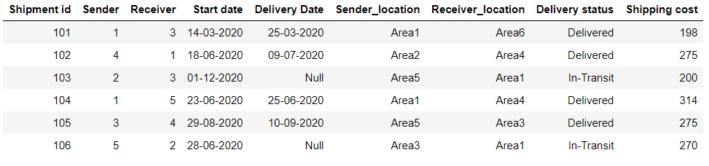
Use below table to refer to client’s data. Please note that a client can be a sender or receiver.
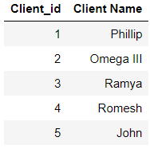
Q1. Create a Dictionary of lists to store the information of shipments given in the table. The key should be the shipment id and the value with it’s details.

Q2. Create a Dictionary to store the information of clients given in the table.

Q3. Write a code to replace client’s id with their respective name in shipment dictionary using a loop and dictionary comprehension

Q4. Print all shipment details that are sent by Phillip

Q5. Print all shipment details that are received by Ramya

Q6. Print all shipments which are in 'In-Transit' status

Q7. Print all shipments which are delivered within 7 days of courier Start date

Q8. Print all shipments which are delivered after 15 days of courier start date or not yet been delivered.

Q9. Print the shipment details whose shipment cost in the range of 200 to 300

Q10. Print the name of all senders whose delivery status is ‘in-transit’.

Q11. Print the shipment ID that has the highest shipment cost.

Q12. Print all the shipment details that are delivered by ‘John’ and received by ‘Omega III’

